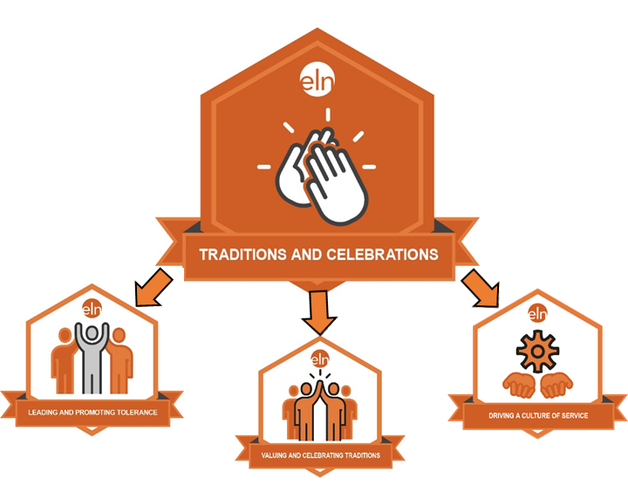
TRADITIONS & CELEBRATIONS
Micro-Credential Pilot - RESTART
Register to Participate

There are three micro-credentials in the Traditions and Celebrations stack: (1) Leading and Promoting Tolerance (2) Valuing and Celebrating Traditions (3) Driving a Culture of Service. Effective mastery of the subskills represented by these micro-credentials encompasses all the skill sets necessary to deploy and sustain a school’s traditions, promote tolerance and drive a culture of service. This micro-credential pilot includes (1) Leading and Promoting Tolerance starting in January. Valuing and Celebrating Traditions and Driving a Culture of Service pilots will begin in February.

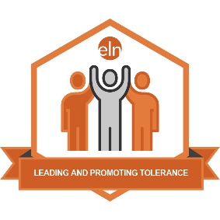
Leading and Promoting Tolerance
In Leading and Promoting Tolerance the practitioner demonstrates the ability to work collaboratively with stakeholders to identify and implement strategies that promote a culture of tolerance. The practitioner will demonstrate their ability to facilitate, model and implement best-practices for creating a culture where tolerance is the norm. The practitioner will provide evidence of the implementation of strategic, evidence-based outcomes; the collection and analysis of stakeholders’ feedback; the monitoring of progress; and the identification of next steps based on data. Finally, the practitioner develops a strategic plan for ongoing monitoring and achievement of the organization’s goals.

Leading and Promoting Tolerance includes the following three identified essential outcomes:
- Models and builds a culture of tolerance.
- Facilitates a collaborative process with stakeholders that promotes and values individual differences.
- Provides a plan with strategies, implementation timelines, evaluation, and progress monitoring to establish, promote, and sustain a culture of tolerance that values individual differences.

Valuing and Celebrating Traditions  In Valuing and Celebrating Traditions the practitioner demonstrates the ability to work collaboratively with stakeholders to identify and implement strategies that promote cultural traditions that recognize, celebrate, and honor students, staff, and community. The practitioner will demonstrate their ability to facilitate, model and implement best-practices for creating inclusive and meaningful celebrations for all stakeholders. The practitioner will provide evidence of the implementation of strategic, evidence-based outcomes; the collection and analysis of stakeholders’ feedback; the monitoring of progress; and the identification of next steps based on data. Finally, the practitioner develops a strategic plan for ongoing monitoring and achievement of the organization’s goals related to the implementation of a culture that values and celebrates traditions and engaging and honoring stakeholders’ achievements.  Valuing and Celebrating Traditions includes the following four identified essential outcomes:  1. Collaborates to ensure inclusive, meaningful recognition and celebration of student achievement  2. Collaborates strategically to ensure inclusive, meaningful recognition and celebration of staff achievement  3. Collaborates to ensure meaningful community involvement in the recognitions, honoring, and celebrating of student and staff achievements  4. Provides a collaborative plan with strategies, implementation timelines, evaluation, and progress monitoring to establish, promote, and sustain a culture that values and celebrates traditions and achievements of students, staff, and community. | 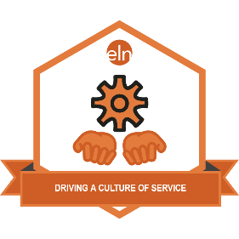  Driving a Culture of Service  In Driving a Culture of Service the practitioner demonstrates the ability to work collaboratively with stakeholders to identify and implement strategies that develop and support an organizational culture of service to others. The practitioner can demonstrate their ability to facilitate, model and implement best-practices for creating a culture of service which includes high quality service-related experiences that meet identified stakeholder needs and develops an on-going commitment to service. The practitioner can provide evidence of the implementation of strategic, evidence-based outcomes; the collection and analysis of stakeholders’ feedback; the monitoring of progress; and the identification of next steps based on data. Finally, the practitioner develops a strategic plan for the ongoing monitoring and achievement of goals related to a culture of service.  Driving a Culture of Service includes the following four essential outcome:  - Promotes a culture of service to all others.  - Supports increased engagement for all stakeholders in service experiences.  - Ensures quality of service projects  - Provides a collaborative plan with strategies, implementation timelines, evaluation, and progress monitoring to establish, promote, and sustain an on-going commitment to a culture of service.

LEADING AND PROMOTING TOLERANCE
VALUING & CELEBRATING TRADITIONS
DRIVING A CULTURE OF SERVICE
Micro-Credential Pilot
Register here to participate and attend the virtual “Getting Started” meeting
Date and Day | Time | Link to Join Virtual MC Pilot Meeting | Phone Dial-in Option
April 17, 2020 | 10 a.m. | Join my meeting from your computer, tablet or smartphone. https://global.gotomeeting.com/join/790369213 | You can also dial in using your phone.  United States:  +1 (646) 749-3122  Access Code: 790-369-213
New to GoToMeeting? Get the app now and be ready when your first meeting starts:
https://global.gotomeeting.com/install/790369213

Pilot Participant Requirements:
- Participate in an online meeting about the program. The purpose of the meeting is to review the micro-credential criteria and requirements and timelines for the pilot.
- Participate in an online, virtual meeting to meet other pilot participants, ask questions and begin your work.
- Throughout the pilot window, you will be required to participate in an online learning community with other pilot participants by responding to brief questions and sharing ideas with other pilots.
- Submit required artifacts to demonstrate your competency within 120 days of beginning the pilot process. Each micro-credential requires you to develop the following four artifacts:
  - Create a responsive narrative (guiding questions provided);
  - Present a portfolio of sample documents;
  - Complete a written analysis of your portfolio contents; and
  - Complete a reflection of your skill development & a dissemination plan to apply your skills.
- Provide feedback to the developers to improve or adjust the micro-credential before public launch.
Pilot Participant Benefits:
- Earn the micro-credential, and its associated digital badge, free of charge.
- Share your new credential via your online presence (email signature, social media, blog, online resume).
- Differentiate your learning to target & strengthen your skill in an important, recognized leadership area.
- Provide evidence of your growth to your stakeholders (evaluator, team, etc.).
- Earn professional development credits or Administrator Academy credit.

