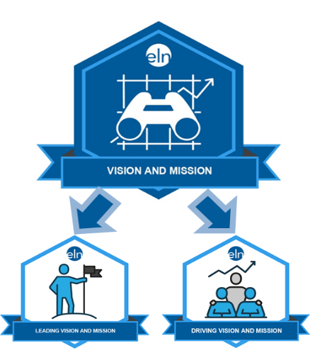
VISION & MISSION
Micro-Credential Pilot - RESTART
Register to Participate

There are two micro-credentials in the Vision and Mission stack: (1) Leading Vision and Mission and (2) Driving Vision and Mission. Effective mastery of leading and driving a school’s vision and mission encompasses all the skill sets and the ability to deploy and sustain them successfully.
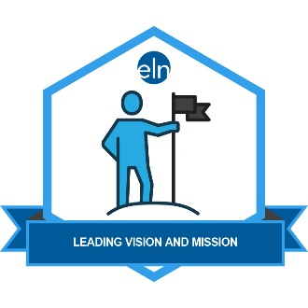  Leading Vision and Mission  In Leading Vision and Mission,  the practitioner displays the  ability to support, articulate, and  foster the organization’s mission  and vision while strategically  and collaboratively determining  and leading the procedural path to intentionally achieve the vision. In addition, the practitioner will have the ability to depict and share stakeholders’ vision of how the organization will appear at its peak performance if the vision is achieved.  Leading Vision and Mission identifies the following four essential outcomes:  - Educational leader evaluates current vision and mission utilizing multiple sources of evidence.  - Educational leader performs a climate/culture and educational review audit to identify and set new expectations for vision and mission.  - Educational leader identifies school core beliefs and values in developing a vision and mission.  - Educational leader reviews resource needs for developing vision and mission plan which ensures academic improvement. | 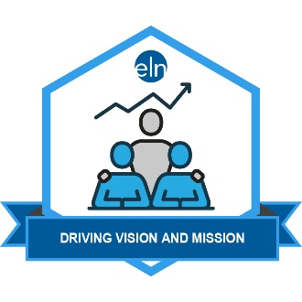  Driving Vision and Mission  In Driving Vision and Mission,  the practitioner clearly conveys  the mission, vision, and direction  of the organization to all  stakeholders, communicating  priorities, intentions, and roles  and responsibilities. By strategically communicating the vision at every opportunity and to every stakeholder group, the leader brands the vision and builds the organization’s reputation of academic success for all students.  Driving Vision and Mission includes the following five identified essential outcomes:  - Create a multi-platform strategy to celebrate successes and advocate for organizational needs and improvement.  - Engage in the community and leverage civic partnerships to advocate on behalf of students and the organization.  - Provide systematic opportunities to invite stakeholders into the organization to provide and promote mutually beneficial outcomes.  - Collaborate with local and national organizations to raise and promote public awareness of the organization.  - Provide a plan with strategies, implementation timelines, evaluation, and monitoring process to establish best practices for communication advocacy.

Vision and Mission Pilot Suggested Prerequisites:
Individuals wishing to participate in the PILOT for each of the two Vision and Mission micro-credentials should have experience in vision and mission development, implementation, and sustainability. Although not all micro-credential pilot programs require prerequisite experience, this skill stack is better suited toward those who have led the mission and vision development process previously. The timeline for the pilot (120 days) is likely to be insufficient for individuals to research and fully implement a vision and mission development process from beginning to end.
LEADING VISION AND MISSION
DRIVING VISION AND MISSION
Micro-Credential Pilot - Restart
Register here to participate and attend the virtual “Getting Started” meeting
Date and Day | Time | Link to Join Virtual Meeting | Phone Dial-in Option
April 17 Friday | 10 a.m. | Join my meeting from your computer, tablet or smartphone. https://global.gotomeeting.com/join/790369213 | You can also dial in using your phone.  United States:  +1 (646) 749-3122  Access Code: 790-369-213
New to GoToMeeting? Get the app now and be ready when your first meeting starts:
https://global.gotomeeting.com/install/790369213

Pilot Participant Requirements:
- Participate in an online meeting about the program. The purpose of the meeting is to review the micro-credential criteria and requirements and timelines for the pilot.
- Participate in an online, virtual meeting to meet other pilot participants, ask questions and begin your work.
- Throughout the pilot window, you will be required to participate in an online learning community with other pilot participants by responding to brief questions and sharing ideas with other pilots.
- Submit required artifacts to demonstrate your competency within 120 days of beginning the pilot process. Each micro-credential requires you to develop the following four artifacts:
  - Create a responsive narrative (guiding questions provided);
  - Present a portfolio of sample documents;
  - Complete a written analysis of your portfolio contents; and
  - Complete a reflection of your skill development & a dissemination plan to apply your skills.
- Provide feedback to the developers to improve or adjust the micro-credential before public launch.

Pilot Participant Benefits:
- Earn the micro-credential, and its associated digital badge, free of charge.
- Share your new credential via your online presence (email signature, social media, blog, online resume).
- Differentiate your learning to target & strengthen your skill in an important, recognized leadership area.
- Provide evidence of your growth to your stakeholders (evaluator, team, etc.).
- Earn professional development credits or Administrator Academy credit. (June 1, 2020 artifact submission deadline for June 30, 2020 Administrator Academy Credit OR September 1, 2020 artifact submission deadline for Fall 2020 Administrator Academy credit.)

